Chemistry Units 1&2 Study Notes
Beaconhills College | Year 11, 2019
Collection of all notes from class, Edrolo and textbooks PERTAINING TO units 1&2 of VCE Chemistry.
Daniel Sandvik
Year 11 2019
Contents
“
Formulae 2
Unit 1 AOS 1 – The Periodic Table 3
The Periodic Table 3
Chemical Properties 4
Alloys, Nanomaterials, etc. 6
Stoichiometry 9
XS Stoichiometry 11
Unit 1 AOS 2 – Materials 13
Bonding 13
Intermolecular Bonding 14
Organic Chemistry 15
Polymers 18
Unit 2 AOS 1 – How do substances interact with water? 21
Water 21
Acids & Bases 24
Redox Reactions 26
Unit 2 AOS 2 – How are substances in water measured and analysed? 29
Water Sample Analysis 29
Measurement of Solubility & Concentration 30
Analysis for Salts in Water 31
Analysis for Organic Compounds in Water 32
Analysis for Acids & Bases in Water 33

Formulae
Definition | Formula
Number of moles of a substance | $n=\frac{m}{M_{r}}$; $n=cV;$ $n=\frac{V}{V_{m}}$; $n=\frac{N}{N_{A}}$
V_{m} | 24.8L/m
Universal gas equation | $$pV=nRT$$
Concentration | $$n=cV$$
Density | $$d=\frac{m}{c}$$
Percentage abundance of an unknown isotope. | $${Ab}_{i}=1-|\frac{A_{r}-m_{i}}{m_{1}-m_{2}}|$$
Percentage mass of an element in a compound. | $$\frac{M_{r}\left(element in 1 mol of compound\right)}{M_{r}\left(compound\right)}*100$$
Converting empirical formula to molecular formula. | $$\frac{M_{r}}{E.F}=x*E.F=MF$$
Energy from specific heat capacity | $$E=mc∆T$$
Dilution Formula | $$C_{1}V_{1}=C_{2}V_{2}$$
Concentration of hydronium from hydroxide and vice versa. | $$\left[OH-\right]=\frac{{10}^{-14}}{\left[H3O+\right]}, \left[H3O+\right]= \frac{{10}^{-14}}{[OH-]}$$
Another hydronium concentration formula | [H₃O⁺] = 10^{-pH}
Basic reaction equations | Acid + Hydroxide -> Salt + Water  Acid + Metal -> Salt + H₂  Acid + Base -> Salt + Water  Acid + Carbonate -> Salt + Water + CO₂  Acid + Oxide -> Salt + Oxide
Expected E⁰ of a cell | E⁰_{cell} = E⁰_{red} – E⁰_{oxi}

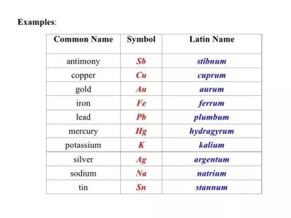
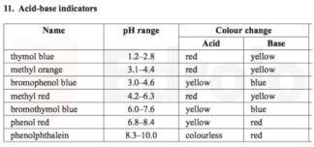
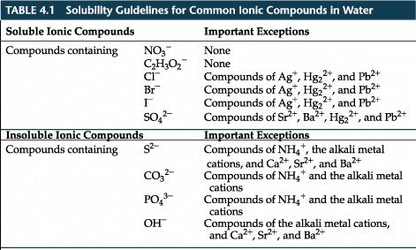
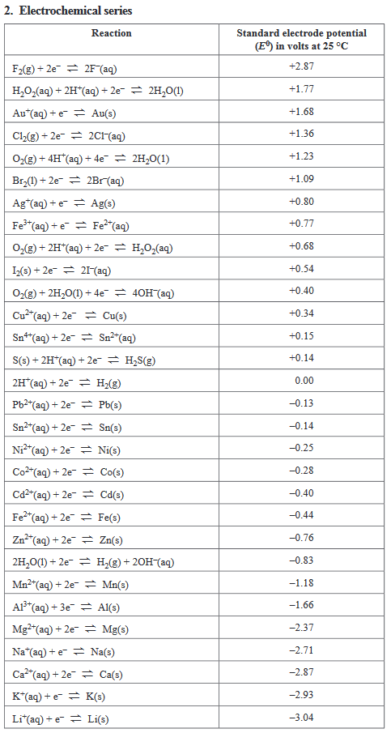
More formulae are found in the VCAA data booklet.
1 - Solubility table
2 - List of Latin-based elements and their respective names.

Unit 1 AOS 1 – The Periodic Table

The Periodic Table
- Relative Size of Particles
  - Particles are the building blocks of all matter.
    - Can be: an atom, sub-atomic (proton, neutron, electron), ion, small molecule (H₂O), giant molecule (DNA), network lattice (diamond), layer lattice (graphite), nanoparticles or nanostructure.
  - Molecules – compounds that only contain non-metals (H, C, O, N, S, P, Cl, Br, I, F)
    - Small molecules
      - E.g. H₂, O₂, CO₂, H₂O, NH₃, C₆H₁₂O₆
    - Large molecules
      - E.g. DNA, protein, carbohydrate, dietary fibre, plastics (synthetic polymers)
  - Lattice – regular arrangement of particles (e.g. bonding within a metal, ionic crystals, covalent structures – diamond, graphite)
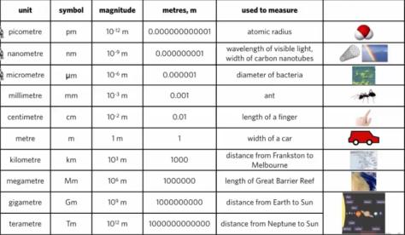
  - Units of Length
    - The metric system is all based off of the metre.
  - Nanoparticles and nanostructures
- Using the Periodic Table as a Map
  - Element – building block of all substances
  - Can be classified as metals, non-metals and metalloids
  - Basic building block of an element is an atom.
  - Any element above 92 (uranium) can only be synthesised in a laboratory.
  - The reason why the lanthanides and actinides are kept separate is to save horizontal space.
  - Periodic table is ordered by atomic number – number of protons.
  - The periodic table gives name, symbol, atomic number, mass number.
  - Mass number is the total number of neutrons and protons in the nucleus of the atom.
  - Periods correspond with number of electron shells.
  - Groups correspond with number of valence electrons.
    - Elements in the same group have similar chemical properties.
- History of the Atom – Key Scientists and Theories
  - Dalton – Identified the atom is a sphere, made of indivisible and indestructible, all atoms of the same element are identical in mass and properties
  - Thomson – plum pudding model; nucleus is positively charged with electrons randomly spread inside. Corpuscles, cathode rays
  - Chadwick – discovery of the neutron
  - Rutherford – gold foil experiment; atom is mostly empty space with a tiny neutron which deflects particles
  - Bohr – electrons travel in separate orbits around the nucleus in shells
  - Schrodinger – electrons exist in a quantum state/probability inside of a cloud, s, p, d, f
- Trends in the Periodic Table
  - Electronegativity decreases down the group.
  - Atomic radius increases down the group.
  - Reactivity of metals increases down a group (weaker valence electron)
  - Reactivity of halogens decreases down a group (electron masking)
- Atomic Structure
  - An atom is the smallest part of an element – has no overall charge.
    - Constructed of protons and neutrons in the nucleus, and electrons in orbitals.
  - Valence electrons – in the outermost electron shell, important in bonding and chemical reactions.
  - Isotopic notation - $\begin{matrix}A \\ Z\end{matrix}X$, A = mass, Z = atomic number, X = element name
  - Isotopes have the same number of protons, but different numbers of neutrons.
- Ions
  - Has an overall charge.
  - If an atom gains electron(s), it becomes negatively charged as an anion.
  - If an atom loses electron(s), it becomes positively charges as a cation.
  - Remember: if asked to draw the structure of an ion to add or remove necessary electrons.
  - If asked to write the atomic number of an ion, the atomic number does not change because of the addition of electrons. Remember the atomic number only refers to the number of protons.
- Subshell Notation of Atoms
  - Within electron shells, there are subshells (s, p, d, f)
  - Within subshells, there are orbitals. (1, 3, 5, 7)
  - Pauli Exclusion Principle – orbital may hold 0, 1 or 2 electrons.
  - Orbital Subshells
    - Each orbital within a subshell corresponds to a different energy level.
  - Notation is filled by numerical order (i.e. [Ar]3d⁶4s²)
- Subshell Notation Ions & Emission Spectra
  - When electrons in atoms or ions absorb energy to move to a higher state, energy is released as they fall back to ground state in the form of photons.
  - Each element has its own ‘fingerprint’ of colours due to differing patterns of electrons.
  - Sulphur – light blue
  - Helium – peach
  - Argon – lavender
  - Hydrogen – fluoro purple
  - Oxygen – white
  - Neon – fluoro red
- Subshell Notation (Copper & Chromium)
  - Chromium (element 24), Copper (element 29)
  - The d-block of elements are more stable if completely full or half full.
  - Therefore, chromium is 1s²2s²2p⁶3s²3p⁶3d⁵4s1
  - Therefore, copper is 1s²2s²2p⁶3s²3p⁶3d¹⁰4s¹

Chemical Properties
- Trends in Properties of Elements
  - Metallic character – ability to lose electrons to become a cation
    - Hydrogen is not a metal, it’s a non-metal.
    - Metalloids share partial characteristics of non-metals and metals.
    - Across to the right of the periodic table, elements decrease in metallic character (non-metal).
    - Down a group, elements increase in metallic character. (low electronegativity/electron attracting power)
  - Atomic radius
    - Core charge – net nuclear charge experienced by a valence electron, increases across a period, stays the same down a group
      - Calculated by number of protons and subtracting the inner shell electrons
      - Considers ‘shielding’ effect of inner electrons.
      - Is always of a positive value.
      - This is calculated by subtracting the inner electrons from the total electron (or reading the group number)
    - Atomic radius decreases as core charges increases because a higher core charge pulls valence electrons closer to the nucleus.
    - Atomic radius increases down a group because more electron shells are added.
    - The ionic radius of Na⁺ is smaller than F⁻ because although they have the same number of electrons, Na has more protons in the nucleus and subsequently has a stronger attractive force on the electrons.
  - Electronegativity
    - “The tendency of an element to attract electrons towards itself.”
    - Noble gases have negligible electronegativity (already full).
    - Across a period and up a group, electronegativity increases.
    - FONCL – decreasing electronegativity goes in fluorine, oxygen, nitrogen, chlorine.
  - First ionisation energy
    - “The amount of energy that an atom in a gaseous state must absorb to release an electron. (become a cation)”
    - The first electron removed is the first ionisation energy.
    - Across a period and up a group, more energy is required.
    - Increasing atomic number = increasing ionisation energy.
    - Noble gases have a greater ionisation energy than other elements.
  - Chemical reactivity
    - Reactivity of metals decreases across a period, but increases down a group.
    - Reactivity of non-metals increases across a period, but decreases down a group.
- Types of Elements and Metallic Bonding
  - D-block metals can form various cations.
  - Common properties of metals
    - Electrically conductive – must contain moveable charged particles
    - Heat conductive
    - Malleable – move when a force is applied
    - Ductile – drawn into wire – move when a force is applied.
    - Lustre – able to reflect light
    - Generally high density – particles are closely held together
    - Generally high melting temperatures – forces between particles must be strong
    - Generally strong
    - Generally hard
  - Metallic bonding model – applies to group 1 and 2 elements.
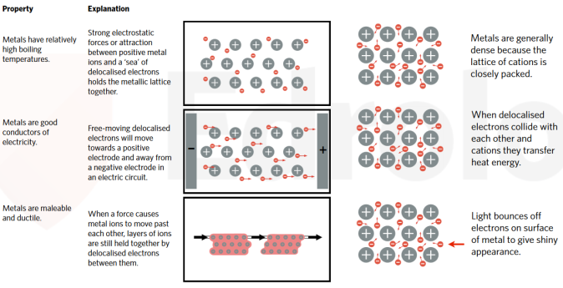
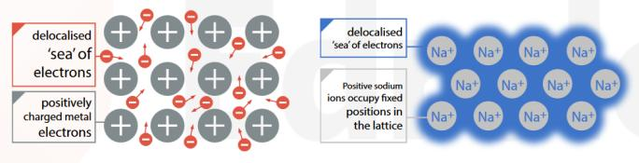
    - Cation lattice held together by sea of delocalised electrons (shared amongst all positive ions)
  - Limitations of the metallic bonding model
    - Does not account for mercury being liquid at room temperature
    - Differences in melting point and densities of various metals
    - Differences in electrical conductivity of various metals
    - Magnetic properties of cobalt, iron and nickel.

Alloys, Nanomaterials, etc.
- Alloys
  - Alloys are compounds of two or more metals.
  - Benefits include:
    - Improved strength (e.g. steel)
    - Resistance to corrosion (e.g. galvanisation)
    - Less malleability (takes more force)
    - Reduced melting temperature (to make materials)
    - Poorer conductor of electricity
  - Substitutional alloys
    - Combination of two or more metals of similar size. (e.g. Australian ‘silver’ coins = 75% copper, 25% nickel)
    - Bronze
    - Brass
    - An ion is substituted for another.
    - Benefits:
      - Layers of lattice are more rigid; less malleable; stronger.
      - Corrosion-resistant
  - Interstitial alloys
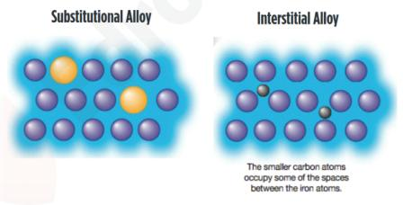
    - Smaller ions fit into small gaps (interstices) between cations. (e.g. steel)
    - Steel
    - Benefits:
      - Layers of lattice are more rigid; less malleable; stronger.
      - Corrosion-resistant
      - Lower melting point allows some movement
- Reactivity of Metals
  - Evidence of a chemical reaction
    - Sound
    - Colour change
    - Bubbles (gas)
    - Disappearance of a reactant
    - Temperature change
  - Reactivity increases going down a group due to valence electrons being further away from the nucleus.
  - Group 1 is extremely reactive with room temperature water, due to valence electron easily being emancipated.
  - Group 2 is not reactive with room temperature water, or very slowly reacting with water, however it will react with steam. This is due to the valence electrons not being as easy to emancipate.
  - Metals are generally more reactive with acid than water.
  - Metal + acid -> salt + H2
  - Acids remove the water from a substance.
  - Reactivity of metals with oxygen
    - Many metals react with oxygen to form metal oxides. Exceptions include gold and platinum.
    - Group 1 reacts quickly, group 2 reacts slower, transition metals react slowly.
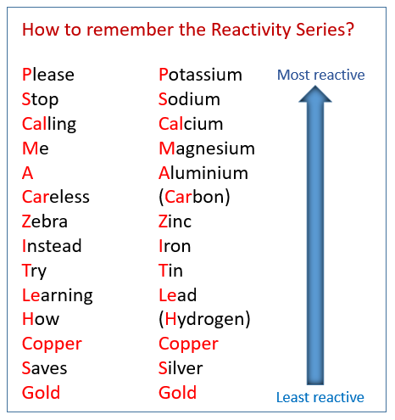
  - Reactivity series of metals
- Extraction of Metal from Ore
  - Aluminium
    - Aluminium is mined from bauxite (as aluminium oxide)
    - Aluminium oxide in bauxite reacts with sodium hydroxide to form sodium aluminate (NaAlO₂)
    - Sodium aluminate reacts with water to form aluminium hydroxide (Al(OH)₃)
    - Aluminium hydroxide is heated to 1000C to form alumina (Al₂O₃)
    - Alumina is dissolved in molten (no water) cryolite (Na₃AlF₆) at 1000C
    - Molten mixture is electrolysed to produce aluminium.
  - Iron
    - Iron ore mainly consists of iron oxide combined with rocky material.
    - Most deposits of iron ore occur in sedimentary rocks (>600 million years old)
    - Formed from chemical reactions which combined iron and oxygen in marine and fresh waters.
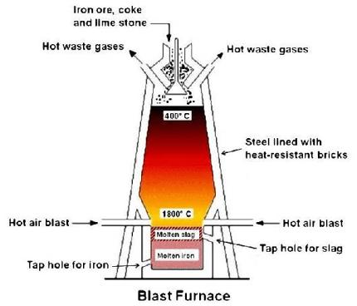
    - In Australia, the iron oxides are in the form of haematite (Fe₂O₃)
    - Other forms such as magnetite (Fe₃O₄) and pyrite/fool’s gold (FeS₂) exist with varying percentage abundances.
    - These forms of iron ore aren’t pure, and may contain other materials such as silica, alumina and
    - Raw materials used in the extraction are: iron ore, coke, limestone, air
    - Iron ore is mined from the ground using open-cut methods and using haul trucks to a typical maximum carrying capacity of 400 tonnes.
    - Coke is a solid containing 80-90% carbon. Used for iron production by heating coal in air-tight ovens, which produces fuel gas (provides heat when burnt), tar, benzene, toluene and ammonium sulphate, which can be used for other chemical industries.
    - Limestone is a sedimentary rock primarily composed of calcium carbonate (CaCO₃), obtained by mining or quarrying and is crushed before use.
    - Blast furnace
      - Tall, bottle shaped tower.
      - 1. Coke reacts with oxygen
      - 2. Carbon monoxide reacts with iron ore
      - 3. Limestone is added to the top of the furnace to form calcium oxide and carbon dioxide and therefore form slag from the unwanted materials.
      - 4. Iron settles to bottom, and slag is less dense and floats to the top, so it decants off and iron is extracted.
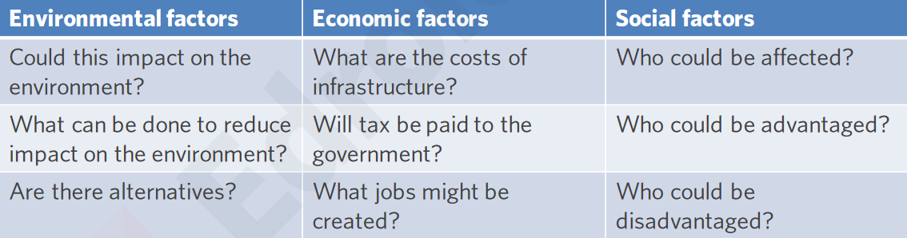
  - Considering environmental, economic and social factors on an issue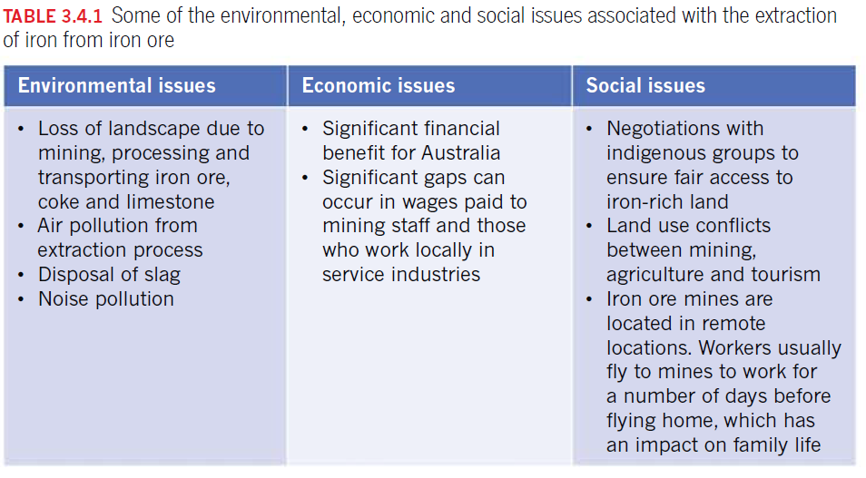

- Modifying Metals
  - Work hardening (cold work)
    - Metals are made of crystals, between each of them having boundaries.
    - Smaller crystals will not allow movement, making it harder. However, it will become more brittle (prone to breaking)
    - Technique where cold metal is hit by a hammer, pushing crystals closer together.
  - Heat treatment of metals
    - Annealing
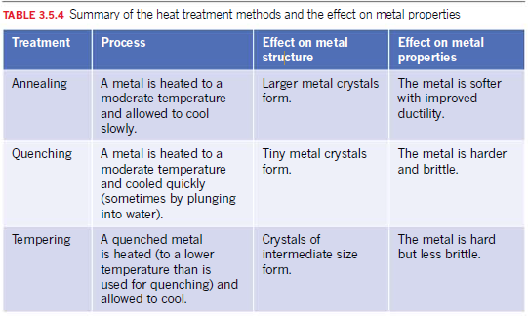
      - Heating metal and cooling slowly.
      - Larger metal crystals
      - Softer metal – more ductile.
    - Quenching
      - Heating metal and cooling rapidly by using cold water
      - Smaller metal crystals
      - Harder metal – more brittle.
    - Tempering
      - Heating metal to below annealing and tempering, allowing to cool slowly.
      - Crystals of intermediate size
      - Harder metal, less brittle.
  - Coatings
    - Prevents corrosion.
    - Steel may be coated with thin layer of tin.
    - Steel may also be coated with a thin layer of zinc (galvanising)
    - Or can use a finish for both aesthetic and anti-corrosive reasons.
- Metal Nanomaterials
  - Nanomaterials have a diameter of 0.1-100nm.
  - Examples of metallic nanomaterials include:
    - Nanoparticles
    - Nanorods
    - Nanowires
  - Nanoparticles have different characteristics and properties compared to the bulk material.
  - Applications of metal nanomaterials
    - Wound dressings with silver nanoparticles (anti-bacterial)
    - In medicine – to target drug delivery
    - Sunscreen – use of zinc oxide to better absorb UV light
    - Electronics
    - Superconductors
- Ionic Bonding and Ionic Compounds
  - Opposites attract.
  - Between a cation (metal) and an anion (non-metal)
  - Ionic compounds have no overall charge.
  - They are also known as salts.
  - Convention is to name cation first, anion ending with ‘-ide’.
  - If there is more than 1 cation and anion, a crystal lattice is formed.
  - Crystal lattice - symmetrical three-dimensional arrangement of atoms inside a crystal.
  - Cation donates valence electrons to the anion.
  - Lattice enthalpy is a measure of the strength of the forces between the ions in an ionic solid. The greater the lattice enthalpy, the stronger the forces. Those forces are only completely broken when the ions are present as gaseous ions, scattered so far apart that there is negligible attraction between them. The size of atoms changes enthalpy, whereby smaller atoms are closer together and thusly strongly attracted. (e.g. NaCl vs. MgO)
  - Electrolyte - A solution or molten substance that conducts electricity by means of the movement of ions
    - Critical in allowing cells to generate energy, maintain the stability of their walls, and to function in general. They generate electricity, contract muscles, move water and fluids within the body, and participate in myriad other activities.
  - Properties of Ionic Compounds
    - High melting & boiling points, all solid at room temperature. (forces between particles are strong)
    - Hard but brittle crystals, unlike metals. (forces between particles are strong)
    - Neither malleable nor ductile
    - Do not conduct electricity in solid state. (no free-moving charged particles)
    - Good conductors of electricity in liquid/molten state or dissolved in water. (free-moving particles are present in this state)
    - Vary from soluble to insoluble in water. Not soluble in non-polar solvents such as oil.
  - Writing the Formula of Ionic Compounds
    - 1. Use Periodic Table to figure out charge of an ion.
    - 2. State cation donates its atoms to the anion(s).
    - 3. Ensure ionic compound has no overall charge.
    - 4. Write cation first, followed by the anion.
- Polyatomic Ions
  - Many atoms.
  - It’s best to remember as many as possible, since there is no pattern.

Stoichiometry
- Relative Isotopic Mass & Relative Atomic Mass
  - Significant figures
    - Non-zero digits are always significant
    - Any zeros between two significant digits are significant
    - A final zero or trailing zeros in the decimal portion ONLY are significant
    - Remember that 0.0632 only has three significant figures, not 5.
  - The mass of all atoms is compared to carbon-12, which has the mass of exactly 12.
  - Relative isotopic mass (I_{r})
  - Mass spectrometry
    - RIM is determined by using a mass spectrometer. It provides information about:
      - Number of isotopes in a given sample of an element
      - RIM of each isotope
      - Relative abundance of each isotope.
  - Relative atomic mass is the average of all isotopes in a given element.
    - $A_{r}\left(X\right)={RIM}_{1}*abundance+{RIM}_{2}*abundance+etc.$
    - Note that the abundance can be in %, however, entire right side has to be divided by 100, or you can convert the abundance to decimals.
    - If a question shows an isotope like boron-10, remember that the 10 is the RIM.
    - If a question says an isotope is “x times abundant as y”, create a ratio and convert to decimals.
  - Percentage abundance is not given.
    - ${Ab}_{i}=1-|\frac{A_{r}-m_{i}}{m_{1}-m_{2}}|$
    - The other abundance can be calculated by finding the difference between the two abundances.
    - Given in ratios:
      - ${Ab}_{i}=\frac{r_{i}}{\sum{(r_{1}+r_{2}+…})}*100$
- The Mole
  - 1 mole = 6.02 x 10²³ = number of carbon-12 atoms in 12g of carbon-12.
  - Avogadro’s Constant
    - 6.02 x 10²³ = N_{A}
  - $Number of moles= \frac{Number of particles}{Avogadro^{'}s constant}$
  - $n=\frac{N}{N_{A}}$
  - This formula can be rearranged to find out the number of moles, number of particles, or Avogadro’s constant.
- Molar Mass
  - Mass of 1 mole = molar mass
  - Calculated exactly the same as before, except with the use of g/mol (grams per mole)
  - Now there is a way to calculate the number of atoms, molecules and ions through weighing.
  - $Number of moles= \frac{Mass}{Molar mass (M_{r})}$
  - $n\left(mol\right)=\frac{m(g)}{M_{r}(g {mol}^{-1})}$
  - These formulas can again be rearranged to suit a question.
  - Remember to write answers in scientific notation.
  - To find the greatest number of atoms in an element, remember mass divided by molar mass. 10g of H atoms (10 mol) is more than 15g of CH₄ (3.75 mol)
  - To find the total number of atoms in a compound, multiply the molar mass by the total number of atoms in the compound (e.g. 0.157 mol * 6 atoms). Then, multiply the new molar mass by Avogadro’s constant to find the total number of atoms.
- Liquids (Concentration)
  - Concentration = No. of particles / volume (n = C*V)
  - $n=cV$
  - c = concentration in mol/L
  - V = volume in litres
- Gases
  - $pV=nRT$
  - p = pressure (kPa)
  - V = volume
  - n = number of moles
  - R (gas constant) = 8.31
  - T = temperature in kelvin
  - $n=\frac{V}{22.4}$ (STP), the volume of 1 mol of any gas is 22.4L
  - $SLC$, volume of 1 mol of any gas at 25C is 24.8L
- Percentage Composition
  - Mass percentage of an element in a compound.
  - $\frac{M_{r}\left(element in 1 mol of compound\right)}{M_{r}\left(compound\right)}*100$
  - $\frac{A_{r}\left(element\right)*no. atoms}{M_{r}(compound}*100$
  - If given the formula, the % composition can be determined by calculating the mass of each element in 1 mole of the compound.
  - E.g. A sample of sodium carbonate (Na₂CO₃) has a mass of 16.6 g. Determine the percentage, by mass, of oxygen in sodium carbonate.
    - $100\left(\frac{\left(3*16.0\right)}{\left(2*23.0\right)+\left(12.0\right)+\left(3*16.0\right)}\right)=45.3\%$
- Empirical & Molecular Formulas
  - The empirical formula is the simplest whole number ratio of atoms in a substance. (e.g. C₆H₆ = CH)
  - If the simplest mole ratio is not close to an integer (±0.1), the values may need to be scaled up
  - Write the moles in the table to 2 decimal places.
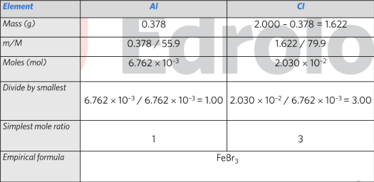
  - If a question states the percentages of the elements within a compound, it already gives the masses in g.
3 - Example of an empirical formula question answered in a table
  - $\frac{M_{r}}{E.F}=x*E.F=MF$
  - Can be rearranged to suit a question.
  - If percentages are given, assume that the total mass is 100 grams so that the mass of each element = the percent given.
  - 1. Convert percentages into mass (g) so total mass is 100g.
  - 2. Divide each mass by the molar mass of the element
  - 3. Divide each ratio by the smallest ratio
  - 4. Multiply each ratio into whole number ratios.
  - 5. Write empirical formula
  - Find Molecular Formula from Empirical Formula
    - Divide the molar mass of the compound by the sum molar mass of each element in the EF.
    - It will result in a whole number scalar, which is then multiplied to the EF.
    - This gives the MF.
- Spectator Ion
  - Remains the same across a reaction and does not interact.
- Stoichiometry – Calculate Amounts of Reactants and Products
  - Using mole ratios to calculate mass of a reactant
    - 1. Balance the equation
    - 2. Which reactants do we already know the amount of? What are we trying to calculate?
    - 3. Convert known reactant amount to moles.
    - 4. Use mole ratio to find moles of another reactant
    - 5. Convert moles to mass.
- Molecular vs. formula mass
  - NaCl - Ionic – formula mass
    - Essentially the sum of masses of the simplest elements in a compound (e.g. Na2Cl2 = 2 * NaCl)
  - C2H6 - Molecular – molecular mass
    - Essentially the sum of masses of the entire molecule.

XS Stoichiometry
- 6NaNO_{2(aq)} + 3H₂SO_{4(aq)} -> 4NO_{(g)} … If a chemist wishes to create 100g of NO gas and has 1.39M NaNO₂ and 2.225M H₂SO₄ what is the minimum volume required of each reactant?
  - 1. Determine number of moles of NO gas (100/30 = 3.333mol)
  - 2. 6mol of NaNO₂ is required for 4mol of NO, therefore the scalar would be 6/4. Then, multiply by the n(NO) to find the n(NaNO₂). (6/4 * 3.333mol = 5.00 mol)
  - 3. Find the volume of NaNO₂ (V = n/c) = 5.00/1.39 = 3.60L
  - 4. Find the number of mol of H₂SO₄ required. 3mol of H₂SO₄ is required to make 4mol of NO = ¾ * n(NO) = 2.50mol
  - 5. Find the volume of H₂SO_{4.} 2.50mol (V = n/c) = 2.50 / 2.225 = 1.12L
- “Determine the concentration of sodium hydroxide solution that would result from the complete reaction of 8.35g of sodium in 180mL of water.”
  - 1. Assume the density of water is 1, therefore, n(H₂O) is 180/18 = 10 mol.
  - 2. Find number of mol of sodium (n = m/M) = 8.35 / 23.0 = 0.363mol. Na is clearly the limiting reagent here.
  - 3. Find the concentration of NaOH. n(Na) = n(NaOH) = 0.363mol. Therefore, c(NaOH) = n/v = 0.363 / 0.180 = 2.02M.

Unit 1 AOS 2 – Materials

Bonding
Materials from Molecules – Covalent Bonding – The Sharing of Electrons
- Metals and Non-metals
  - Most elements in the periodic table are metals.
  - The staircase-type line are the metalloids
  - Everything to the right of the staircase are non-metals.
  - Common non-metals are carbon, nitrogen, oxygen, phosphorus, sulphur, halogens and hydrogen.
- Covalent (Intramolecular) Bonding
  - Bonding between two or more non-metal atoms.
  - Sharing of valence electrons. (co-valence)
  - Two covalently bonded non-metals create a diatomic molecule.
- Hydrogen (not a metal!)
  - Due to hydrogen only having one electron, it is very unstable. Therefore, it collides with another hydrogen atom to make a more stable H₂ gas.
  - The two valence electrons now share between both atoms.
  - Covalent bonds can be represented as a line in structural formula.
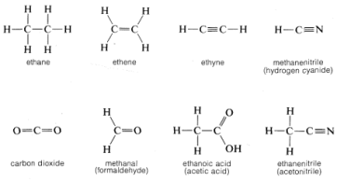
- Fluorine
  - Fluorine, like hydrogen forms F₂ gas, which is more stable than the elemental form.
Materials from Molecules – Representations of Molecules
- Bonding Pairs and Lone Pairs
  - Not all the valence electrons will become bonding pairs (generally only one, two or three pairs will)
    - Single covalent bond, double covalent bond, triple covalent bond
  - Lone (non-bonding) pairs – electron pairs that are not involved with bonding.
  - Like charges repel, therefore the lone pairs of electrons want to be as far away as possible.
  - E.g. I₂ has one bonding pair and six lone pairs (three for each iodine atom)
- Representing Molecules
Materials from Molecules – VSEPR and the Shape of Molecules
- NOTE: structural formula is the same as valence structure.
- Diatomic molecules are linear.
- Molecules containing >2 atoms
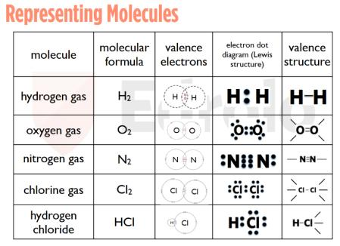
  - Although some diagrams seem to imply that these shapes are 2D, they are 3D.
  - More advanced notations of structural formula show dimensions.
- VSEPR (Valence Shell Electron Pair Repulsion)
  - Pairs of electrons in valence shell repel each other, therefore they want to be as far away as possible.
  - 8 electrons in a shell/4 pairs, therefore they spread out in a tetrahedron shape.
- Structure Adjectives
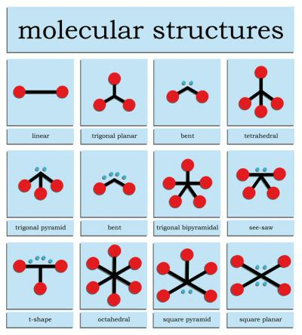
  - Pyramidal (e.g. NH₃)
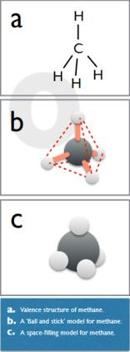
  - V-shaped (e.g. H₂O)
  - Linear
  - Tetrahedral
  - Trigonal bipyramid
  - See-saw
  - T-shape
  - Octahedral
  - Square pyramid
  - Square planar

Intermolecular Bonding
- Different to intramolecular bonding (covalent bonding).
- Refers to bonding that occurs between molecules.
- Covalent and ionic bonds are much stronger than any intermolecular forces because they involve the donation or sharing of electrons to satisfy the octet rule with full charges, whereas intermolecular bonding only involve electrostatic interactions with partial charges, not full charges.
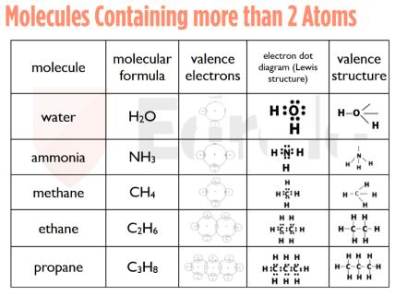
- Electronegativity
  - Refers to how easily an atom attracts electrons towards itself.
  - Increases up and to the right of the periodic table
  - Fluorine is the most electronegative.
  - FONCl is the order of decreasing negativity of elements.
- Polarity of Covalent Bonds
  - When there is a significant difference in electronegativity between two non-metals, a polarised bond or dipole can result.
  - In a polarised covalent bond, the pair of shared electrons spends more time closer to the electronegative element.
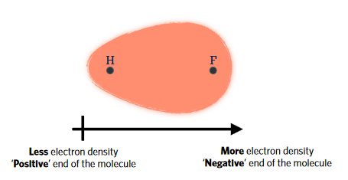
  - We use the symbol delta (δ^{+/-}) to identify the positive pole and the negative pole.
- Is a Molecule Polar?
  - The presence of 1 or more dipoles can result in the overall shape being polar.
  - Look for symmetry. If the dipoles are symmetrical, they cancel out and become non-polar.
  - Remember FONCl will influence where the electrons will spend more time in, therefore creating polarity or non-polarity depending on the symmetry.
  - Elemental molecules are non-polar.
- Carbon-Hydrogen Bonds (Hydrocarbons)
  - Carbon and hydrogen are very similar in electronegativity, and are therefore non-polar.
  - Molecules containing only carbon and hydrogen (hydrocarbons) are non-polar.
- Dipole-Dipole Interactions
  - When two polar molecules interact
  - Slightly positive pole attracted to slightly negative pole.
  - The greater the polarity, the greater the attraction

- Hydrogen Bonding
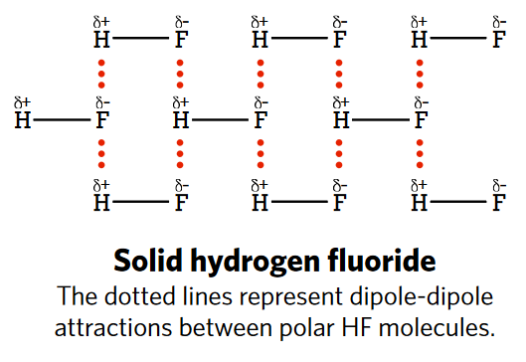
  - Strongest form of dipole-dipole interactions/intermolecular bonds
  - Occurs in molecules with hydrogen covalently bonded with oxygen, nitrogen or fluorine.
  - Creates significant positive charge on hydrogen and negative charge on the non-metals due to high electronegativity.
  - Non-metals must have lone pair(s).
  - Involves H and one other non-metal besides carbon (e.g. O, N)
  - H-FON, NOT FONCL.
  - Water expands (becomes less dense) as it freezes because hydrogen bonds form between the molecules, creating an open ring structure.
- Dispersion Forces (Van der Waal’s forces)
  - Instantaneous dipoles.
  - Weakest form of intermolecular interactions
  - Attraction between temporary dipoles in a quantum state. These are named instantaneous dipoles/dispersion forces/Van der Waal’s forces.
  - Responsible for what state an atom is in.
    - Iodine crystals sublimate when heated because the crystals are heavy but the weak dispersion forces break when heated, leading to sublimation.
  - Typically occurs when cooling atoms down.
  - Dispersion forces are the only forces acting on non-polar molecules. (i.e. hydrocarbons)
  - Stronger between larger molecules (i.e. higher melting/boiling point)
  - Non-polar bonds such as I₂ do not dissolve as well in polar solvents (e.g. water) because the dispersion forces between the I₂ molecules cannot compete with the hydrogen bonds in water.
  - However, non-polar bonds dissolve well in non-polar solvents (e.g. alkanes) because the dispersion forces can compete with the dispersion forces with the non-polar solvents.
- Order of bonds
  - Covalent -> Hydrogen -> dipole-dipole -> dispersion
Carbon Lattices and Nanomaterials
- Substances with the same element but different physical properties are allotropes (e.g. diamond, graphite, charcoal)
- Diamond is in a network lattice. Sublimes at >3500C. Each carbon is bound to four other carbon atoms, making the intramolecular forces extremely high. It does not conduct electricity because there are no free electrons.
- Graphite is in a layer lattice. Sublimes at >3500C. Carbon layers arrange hexagonally, and the layers are bound together by comparatively weak dispersion (intermolecular) forces and thusly can slide over each other and therefore leave imprints on paper. However, the covalent bonds between each carbon in a layer is still very strong, making the sublimation point similar of diamond. Graphite can conduct electricity because there are delocalised electrons shared between the layers.

Organic Chemistry
Organic Compounds – Crude Oil & Hydrocarbons
- Organic chemistry is the chemistry of organisms (living or dead), and is mostly carbon chemistry.
- Crude oil (petroleum)
  - Type of fossil fuel
  - Liquid remains of organisms living millions of years ago (e.g. plankton, blue-green algae and microorganisms)
    - Dead organisms living in water were quickly covered by sediment and formed into sedimentary rock. Over time, the dead organisms decomposed into crude oil and thusly found trapped between rock layers.
  - Mixture of compounds
    - Contains many hydrocarbons (incl. alkanes)
  - Composition
    - Carbon (80-90%)
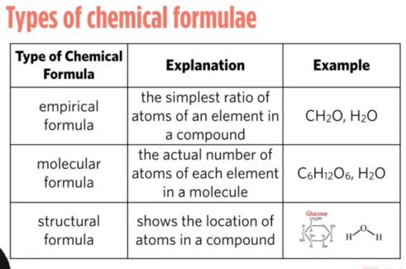
    - Hydrogen (10-14%)
    - Minor quantities of nitrogen, oxygen, sulphur.
  - Uses
    - Depending on the size of the molecules when refined, it separates into fractions
    - Bottled gas, aircraft fuel, car fuel, diesel, heating oil, fuel oil (power stations), bitumen (roads) and the residue can be used to make plastics (giant molecules)
Organic Compounds – Alkanes
- Saturated (single bond) hydrocarbons (hydrogen & carbon only)
  - Alkanes (C_{n}H_{2n+2})
    - Homologous series (family of compounds)
      - Series of compounds with the same functional group and similar chemical properties in which the members of the series differ by the number of repeating units they contain.
      - Differ by CH₂
      - Have very similar chemical properties
    - Alkanes have single bonds between C atoms
      - They are ‘saturated’ – where Cs aren’t bonded to each other, H are bonded to C.
    - Carbon – black, hydrogen – white, oxygen – red, nitrogen – blue
    - Draw the structural formula with approximate 109 degrees of separation between each carbon (creating a bent chain)
    - Methane (CH₄)
      - First member of alkanes
      - All covalent bonds are single bonded.
      - Tetrahedral shape
      - Used as a flammable gas
    - Ethane (C₂H₆)
      - Second member
      - 2 carbons form ‘backbone’
      - Each H bonded to one C atom (i.e. CH₃CH₃)
      - All covalent bonds are single bonded.
      - Starting material to manufacture plastics.
    - Propane (C₃H₈)
      - Third member
      - 3 carbons form ‘backbone’
      - Each H is bound to one C (i.e. CH₃CH₂CH₃)
      - All covalent bonds are single bonded.
    - Butane (C₄H₁₀)
      - Fourth member
      - 4 carbons form ‘backbone’
      - Each H is bound to one C (i.e. CH₃CH₂CH₂CH₃)
      - All covalent bonds are single bonded.
    - The rest of the family members follows a systematic nomenclature.
    - Melting and boiling points increase as the molecule grows larger, due to more electrons engaging in dispersion forces between the molecules.
    - Insoluble in water (because water is polar and alkanes are non-polar)
    - Combustible
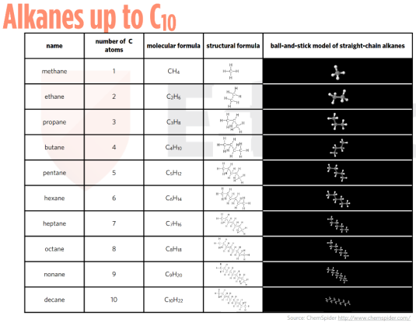
  - Alkenes
  - Alkynes
  - Non-polar because electronegativity difference between carbon and hydrogen is minimal and they are mostly symmetrical.
Organic Compounds – Alkyl Groups & Isomers
- Semi-structural formula (e.g. CH₃CH₃)
- Repetitions can be put in brackets (e.g. CH₃(CH₂)₇CH₃)
- Substituents can be notated in semi-structural form by writing the carbon atom in question and put adjacent brackets with the substituents (e.g. CH₃CH(CH₃)CH₃)
- Alkyl group is an alkane, removing one H atom. (e.g. methyl- = CH₃, pentyl- = C₅H₁₁)
- The end group loses a hydrogen. (i.e. CH₃CH₂CH₂- or CH₃(CH₂)₂-)
- Isomers are the same molecular compound but arranged structurally differently.
- Naming organic compounds
  - 1. Identify longest carbon chain
  - 2. Number the carbons
  - 3. Side groups: use alkyl prefix to number side group with smallest possible number.
  - 4. Use prefix di-, tri-, tetra, etc. to show how many side groups are present.
  - 5. Abbreviate name if possible.
Organic Compounds – Alkenes and Alkynes
- Alkenes – homologous series of hydrocarbons with one C-C double bond
  - C_{n}H_{2n}
  - Starts with eth-, as it needs a double bond.
  - There are only set structures for ethene and propene, not for any subsequent ones due to needing to create isomers for different positions.
  - Isomers can be written as but-1-ene or 1-butene for example.
  - Write semi-structural formula notating the double bond with = between the respective carbons. Any substituents must be written in parentheses adjacent to the carbon location in question
- Alkynes – homologous series of hydrocarbons with one C-C triple bond
  - C_{n}H_{2n-2}
  - Starts with eth-, as it needs a triple bond.
  - Like alkenes, there aren’t set structures for propyne onwards.
  - Isomers need to be drawn.
- Alkenes and alkynes are unsaturated due to the presence of a double or triple bond between carbons.
Organic Compounds – Alcohols
- Contain an -OH functional group.
- Essentially the same as alkanes, except there is a hydroxyl instead of a hydrogen on the end. (e.g. methanol = CH₄O/CH₃OH)
- However, propanol onwards, the functional group can be attached in other places.
- The bigger the alcohol molecule, the larger the boiling and melting points. This is due to hydrogen bonds forming between molecules, which are much stronger than dispersion forces.
- Alcohols will be liquid at room temperature.
- Alcohols can dissolve in water by forming hydrogen bonds with water and are polar.
- Longer-chain alcohols become less soluble due to non-polar carbon chains.
- Engage in hydrogen bonding.
Organic Compounds – Carboxylic Acids
- C=O (-OOH)
- Carboxyl group is always on an end carbon (always labelled 1). Always start counting carbons from the functional group.
- Due to having two oxygen molecules, this makes carboxyl groups more polar than alcohols.
- Methanoic acid, ethanoic acid, propanoic acid, butanoic acid, etc. (CH₂O₂ or HCOOH)
Organic Compounds – Esters
- Generally, have an odour.
- Alcohol + carboxylic acid -> Ester + water
- Esterification reaction (condensation reaction)
- Ester functional group is -OO- (-oate)
- Predict the reactants used to form the ester by reading the alcohol and carboxylic acid from the molecule.
Functional Groups in Organic Chemistry
- Alkene
- Alkyne
- Alkanol (alcohol), -OH (hydroxyl group)
- -COOH (carboxyl group) carboxylic acid (alkanoic acid)
- R-COO-R (ester)
- R-NH₂ (amine)
- R-X (Halide/halogens)
- R-O-R’ (ethers/glycosidic links)
- R-CONH-R’ (amides/peptide bonds)
- Functional groups are chemically reactive.
- Homologous series containing functional groups will also be chemically reactive.
Reactions with Functional Groups
- Substitution
  - Replace functional group with another compound (e.g. chloroethane + sodium hydroxide -> ethanol + sodium chloride)
- Addition
  - Add in atoms.
  - Needs to happen across a double bond (unsaturated)
  - E.g. Ethene + hydrochloric acid -> Chloroethane

Polymers
Polymers – Addition Polymers
- Many monomers.
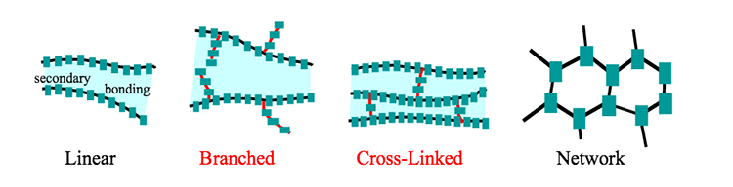
- A monomer is a building block/simplest part of a polymer.
4 - Linear cannot recycle, branched and cross-linked can.
- Add atoms across carbon-carbon double bond in an alkene. (e.g. Ethene + H₂ -> Ethane)
- Can also work adding acids (e.g. Ethene + HCl -> Chloroethane)
- Can also work adding halogen liquids (e.g. Ethene + Br₂ -> 1,2-dibromoethane)
- Addition polymerization
  - Add many of an alkene to make a polyalkene (e.g. ethene * n -> polyethene)
  - Note that even though there is no double bond, it’s still referred to as an alkene.
  - Polyethene can be used as clingwrap and plastic bottles.
  - Polychloroethene, polyvinylchloride (PVC) or simply vinyl chloride is formed from polymers of chloroethene.
  - Benzene/cyclohexatriene (C₆H₆) forms a hexagonal ring with alternating double-single bonds
    - Can be drawn in a skeletal structure
    - Can be drawn with a circle inside a hexagon, showing 6 delocalised electrons being shared between the carbons
  - Polystyrene – ethene with one hydrogen replaced with a benzene, typically used as packing material
  - Teflon/polytetrafluoroethylene/PTFE – ethene with 4 fluoride ions often used as a non-stick coating in frying pans
  - Polypropene – propene with carbon single bonds, used in Australian bank notes
Polymers – Thermoplastic and Thermosetting Polymers
- $density=\frac{mass}{volume}$ or $d=\frac{m}{V}$
- Specify the units used to measure (e.g. g/L, mg/mL, kg/ML, etc.)
- Types of Polyethene
  - Low density polyethene (LDPE)
    - High degree of branching
    - Very plastic (can remould when heated)
    - E.g. cling film
    - Transparent
  - High density polyethene (HDPE)
    - Low degree of branching (polymer chains can pack neatly)
    - More brittle
    - E.g. milk bottle
    - Often appear translucent due to crystalline regions scattering light
- Location of methyl side groups
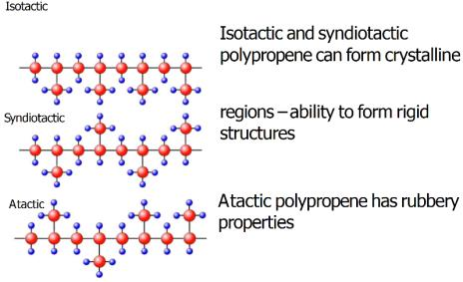
  - Isotactic
    - Side groups all on the same side of the polymer
    - Polymer chains can pack neatly together
    - Baby formula bottles, rope, outdoor clothing
    - Can form crystalline structures
  - Syndiotactic
    - Alternating side group locations (i.e. switches from side to side)
    - Able to form rigid structures
  - Atactic
    - Side groups randomly distributed
    - Very soft, useful as a grease
    - Has rubbery properties
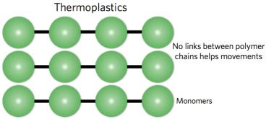
- Thermoplastic Polymers
  - Can be reheated and reshaped (plasticity), e.g. polyethene
  - Bonds between chains are dispersion forces
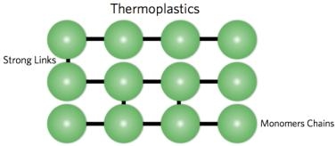
  - By adding heat, the dispersion forces are disrupted by increasing vibrational (kinetic) energy and allows the layers to slide over, reshaping.
  - Melts.
- Thermosetting Polymers
  - When heat is applied, the molecule becomes rigid e.g. melamine
  - Covalent bonds form between the layers
  - Decomposes.
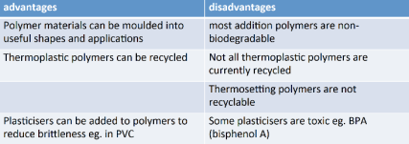
- Advantages and disadvantages of polymers
  - Advantages
    - Can be moulded into useful shapes and applications
    - Thermoplastic polymers can be recycled
    - Plasticisers can be added to polymers to reduce brittleness (e.g. PVC)
  - Disadvantages
    - Most addition polymers are not biodegradable
    - Not all thermoplastic materials are recycled
    - Thermosetting polymers are not recyclable
    - Some plasticisers are toxic (e.g. BPA [bisphenol A])
Copolymers
- Polymer made from at least two different monomers
- Alters chemical and physical properties.
- Can occur via addition or condensation polymerization.
- Chain length
  - Increasing chain length increases the net strength or dispersion forces, strengthening the polymer.
- Extent of branching
- Arrangement of side groups
Polymers – Condensation Polymers
- Condensation polymerisation
  - Forms molecules such as DNA and haemoglobin as well as starches
  - Polymer + water is made (esterification)
  - Requires at least two functional groups.
    - Hydroxyl, carboxylic, acid, ester
    - Can make diacids, diols and diesters for example
- Nylon - Condensation copolymer
  - More than one monomer
  - Hexanedioic acid (6 carbons, 2 carboxyl groups)
  - 1,6-hexanediamine (6 carbons, 2 amines)
  - nHOOC(CH₂)₄COOH + nH₂N(CH₂)₆NH₂
  - Take hydroxyl from the carboxylic acid, and a hydrogen from an amine to form water. Hence, condensation.
  - This bonds the carbon into an amide linkage.
- Polyethene Terephthalate (PET)
  - Ethylene glycol (1,3-ethanediol)
  - Terephthalic acid
  - HOCH₂CH₂OH + HOOC₆H₄COOH

Unit 2 AOS 1 – How do substances interact with water?

Water
Properties of Water – Interactions with Other Molecules
- Ionic substances pulled out of the lattice by water and become surrounded by H₂O molecules are said to be hydrated.
- The process of separating a solid ionic compound to form hydrated ions is called dissociation.
- Not all ionic compounds dissolve in water. (e.g. limestone CaCO₃)
- Some nonpolar molecules can still by partially dissolved in water (e.g. induced dipole through repulsive charges)
- SNAPE Rule
  - Lists most of the soluble salts that contain one or more of the following soluble ions:
  - Sodium (Na⁺)
  - Nitrate (NO₃⁻)
  - Ammonium (NH₄⁺)
  - Potassium (K⁺)
  - Ethanoate (CH₃COO-)
Properties of Water – Solutions, Colloids, Suspensions, etc.
- Solution
  - Homogenous (equal distribution) of two or more substances.
  - Clear
  - <10⁻¹⁰ m particles
  - Does not settle
  - Filter paper does not work
  - Distillable
  - Saturated
    - No more solute can dissolve at a temperature
  - Unsaturated
    - More solute can dissolve at a temperature
  - Supersaturated
    - Unstable solution containing more solute than normal (usually heated) and can be easily broken if disturbed.
- Colloid
  - Homogenous
  - Cloudy
  - Between 10⁻¹⁰ m and 10⁻⁷ m particles
  - Can see particles
  - Does not settle
  - Filter paper does not work
  - Distillable
- Suspension
  - Not homogenous
  - Visible particles of at least two different types
  - >10⁻⁷ m particles
  - Settles in standing solution
  - Filterable (filter paper)
- Dilution
  - Reduction of solute concentration by adding more solvent.
  - C₁V₁ = C₂V₂
- Crystallisation
  - Solidification of atoms or molecules into a highly structured form
Properties of Water – Trends of Group 16 Hydrides
- Water is a very important solvent.
- Water is polar covalent
- Undergo hydrogen bonding (strongest intermolecular force & dipole-dipole bonding)
- H2O, H2S, H2Se, H2Te
  - Hydrogen sulphide has a significantly lowered boiling point, but each subsequent group 16 hydride has a melting/boiling point climbing back up, but never to the level of H2O.
  - As the molar mass of the group 16 hydrides increases, the MP and BP increases. This is because the number of electrons in the molecules increases, therefore allowing more stronger dispersion forces (which require more energy to break apart), hence having a higher MP/BP.
- Why does water not follow these trends?
  - Water has a lower molar mass (18.0g/mol)
  - Can undergo hydrogen bonding (H-FON)
  - Other group 16 hydrides cannot form hydrogen bonds, at best only dipole-dipole bonds.
- All group 16 hydrides are polar and V-shaped due to the formation of dipoles.
Properties of Water – Latent Heat
- Heat vs. Temperature
  - Temperature is a measure of average kinetic energy of a substance in °C.
  - Heat is the transfer of energy from a body of higher temperature to a lower temperature in J.
- Latent heat
  - The amount of energy required to change state.
  - Latent heat of fusion (kJ/mol) – amount of energy required to change from a solid to a liquid without a temperature difference. Less energy required, compare to vaporisation
  - Latent heat of vaporisation (kJ/mol) – amount of energy required to change from a liquid to a gas without a temperature difference. More energy required, compare to fusion
  - Endothermic reaction – amount of energy absorbed from the external environment.
  - As more heat is absorbed, the temperature increases.
  - Watch out for when a question says “molecule”. Substances such as iron are not considered to be molecules.
- Significance of high latent heat of vaporisation of water
  - Prevents cells from overheating.
  - During perspiration, 44.0kJ/mol of water is transferred from the body to the environment to lead to cooling.
  - The high latent heat of vaporisation means that the cooling effect is efficient (little water is lost during cooling)
Properties of Water – Specific Heat Capacity
- A material with high heat capacity has the advantage to perform its function without overheating too quickly. Think of CPU thermals, car engines, etc that can convert plenty of electricity or fuel without overheating.
- Amount of energy needed to raise the temperature per unit mass of a substance by 1°C.
- J/g/°C
- Higher specific heat capacity value = more effective at storing heat (energy)
- Why does water have a high specific heat capacity?
  - Energy needs to be absorbed by the water molecules to overcome intermolecular bonds (hydrogen bonds)
  - Hydrogen bonds are very strong, therefore allowing a very high specific heat capacity.
- Calculating energy from specific heat capacity.
  - $E=mc∆T$
  - Remember MCAT
  - E = energy (J)
  - m = mass (g)
  - c = specific heat capacity (J/g/°C)
  - $∆T$ = change in temperature (°C)
  - What is the energy required to raise the temperature of 1.0kg of water by 20°C?
    - E = 1000 * 4.18 * 20 = 84kJ.
  - Remember to watch out for kJ, J, kg and g. Convert properly first.
Water as a Solvent – Substances that Dissolve in Water
- Key terms
  - Solvent – what solute is dissolved in
  - Solute – what is dissolved in the solvent
  - Solution – combination of solvent and solute as particles
  - Solubility – measure of how readily a solute dissolve in a solvent
  - Dissolution – process of dissolving a solute in solvent
  - Ionisation – process of ionising a molecule in a solvent
  - Dissociation – process of dissociating an ionic compound into constituent ions in a solvent
- For a solute to dissolve in a solvent…
  - Intermolecular forces between solute particles must be overcome
  - Intermolecular forces between some solvent particles must be overcome
  - New forces must exist between solute and some solvent particles.
- Substances that dissolve in water
  - Polar covalent molecules (hydrogen bond, e.g. ethanol + water)
  - Polar covalent molecules (ionisable, e.g. HCl + H₂O -> Cl⁻ + H₃O⁺ [hydronium ions])
  - Ionic compounds that dissociate
- Dissociation of an ionic compound in water
  - Ionic bonds between solute breaks and hydrogen bonds between water breaks.
  - Ion-dipole attractions between ions and polar water molecules form
Water as a Solvent – Precipitation Reactions
- Cations and anions from two or more substances separate from water, allowing them to combine and form a solid.
- Two ionic solutions mixed to create a solid.
- A_{(aq)} + B_{(aq)} -> Precipitate_{(s)} + C_{(aq)}
- PANES – highly soluble
  - Potassium
  - Ammonium
  - Nitrate
  - Ethanoate (CH3COO⁻)
  - Sodium
- CHOPS – insoluble, precipitate
  - Carbonate
  - Hydroxide
  - Oxide
  - Phosphate
  - Sulphide (don’t confuse with sulphate or sulphite)
- Exceptions – precipitates (insoluble) often include these
  - Silver ion
  - Lead (II) ion
  - Mercury (I) ion
  - Calcium ion
  - Barium ion
- Group 1 metal ions tend to be very soluble in water, group 2 tend to be insoluble.
Water as a Solvent – Writing Balanced Ionic Equations
- Ionic equation – a form of chemical equation that only shows the species involved in a reaction.
- Spectator ions – ions not involved in the reaction.
- Look at the state of the ions – if these ions are aqueous as both reactants and products, (i.e. haven’t changed state), then they are spectator ions.
- E.g. AgNO_{3(aq)} + NaCl_{(aq)} -> AgCl_{(s)} + NaNO_{3(aq);} Na⁺_{(aq)} and NO₃⁻_{(aq)} are spectator ions
- Writing an ionic equation
  - Only show species involved in the reaction.
  - Start with a balanced full equation.
  - Identify spectator ions and remove them from the full equation to make an ionic equation.
  - Remember to write the charges on the ions.
  - Put the metal cations first before the other substance.
  - E.g. AgNO_{3(aq)} + NaCl_{(aq)} -> AgCl_{(s)} + NaNO_{3(aq)}; Ag⁺_{(aq)} + Cl⁻_{(aq)} -> AgCl_{(s)}

Acids & Bases
Acids & Bases - Lowry-Brønsted Theory
- Protons are H⁺
- Acids are proton donors. Taste sour, molecular in structure and form conducting solutions. Also turns blue litmus paper red.
- Bases are proton acceptors
- When acids and bases react together, it causes a neutralisation reaction.
- Acid + Base -> Salt + H₂O
- Mineral acid
  - Does not contain hydrocarbon bonds
- Organic acid
  - Contains hydrocarbon bonds
- Amphiprotic species
  - Acts as an acid or base (donate or accept H⁺)
  - Uses the equilibrium arrows.
  - E.g. self-ionisation of water
    - H₂O_{(l)} + H₂O_{(l)} ⇌ OH⁻_{(aq)} + H₃O⁺_{(aq)}
- Polyprotic acids
  - Can donate >1 proton (H⁺)
  - E.g. H₂SO_{4(aq)} + H₂O_{(l)} -> HSO4-(aq) + H3O+(aq)
  - HSO4-(aq) + H2O(l) ⇌ SO42-(aq) + H3O+(aq)
Acids & Bases – Spectator Ions, Conjugate Acid-Base Pairs
- Conjugate acid-base pairs differ by one proton (H⁺)
- When an acid donates a proton to water, one of the products is a conjugate base of the acid.
- HCl/Cl+, H2O/OH-
Acids & Bases – Strong & Weak Acids, Strong & Weak Bases
- Strong Acid vs. Weak Acids
  - Strong acids ionise almost completely in water.
    - E.g. HCl(aq) + H2O(l) -> Cl-(aq) + H3O+(aq)
    - -> means complete
  - Differs to ‘concentrated.’
  - Weak acids ionise partially in water.
    - CH3COOH(aq) + H2O(l) ⇌ CH3COO-(aq) + H3O+(aq)
    - ⇌ means equilibrium.
- Strong Bases vs. Weak Bases
  - Strong bases readily accept a proton from water to form a hydroxide ion (OH⁻)
    - E.g. O2-(aq) + H2O(l) -> 2OH-(aq)
  - Weak bases do not readily accept a proton from water to form hydroxide ion
    - E.g. NH3(g) + H2O(l) ⇌ NH4+(aq) + OH-(aq)
- Neutralisation reactions of strong and weak acids
  - Ability of an acid to neutralise a base does NOT depend on whether the acid is weak or strong.
  - E.g. HNO3(aq) + NaOH(aq) -> NaNO3(aq) + H2O(l) [strong acid, strong base]
  - E.g. CH3CH2COOH + NaOH(aq) -> CH3CH2COONa(aq) + H2O(l) [weak acid, strong base]
  - When writing organic ionic compounds containing metal cations, cations are written last, but said first. (e.g. CH3CH2COONa; Sodium propanoate)
- 5.00g of zinc metal is added to 25.00mL of 1.500M sulphuric acid.
  - a) Will all of the zinc dissolve? Which species is in excess? (Use n = m/M and n = cV)
  - b) What will be the pH of the final solution?
Acids & Bases – pH
- Mathematica commands
  - Log[b,z]
  - Log10
- The pH (potential of hydrogen) scales
  - 0-14, acid-base
  - Logarithmic scale
  - p = potential, H = concentration of hydrogen ions (H⁺)
  - pH = -log₁₀[H₃O⁺] (low pH, acid)
  - pOH = -log₁₀[OH⁻] (high pH, base)
  - [H₃O⁺] = 10^{-pH}
  - These are inverse relations (log is the opposite of ^)
  - [] mean concentration in molarity M or mol/L.
  - At 25C, the pH of pure water is 7.0. This means the concentration of H₃O⁺ at 25C is 10⁻⁷.
  - What is the pH of 0.01M HCl?
    - 1. Write a balanced equation for the reaction of HCl with H₂O.
      - HCl_{(aq)} + H₂O_{(l)} -> Cl⁻_{(aq)} + H₃O⁺_{(aq)}
    - 2. For a strong acid, the concentration of acid = concentration of hydronium ions. (assume acid ionises completely)
      - [HCl] = [H₃O⁺]
0.01M = 0.01M
    - 3. Substitute into pH formula
      - pH = -log₁₀[H₃O⁺]
      - =-log₁₀[0.01]
      - =-(-2)
      - =2
      - Highly acidic.
  - What is the concentration of hydronium ions in a solution of pH 3?
    - [H₃O⁺] = 10^{-pH}
    - =1 * 10⁻³ M
    - =0.001 M (mol/L)
- The Ionic Product of Water
  - H₂O_{(l)} + H₂O_{(l)} ⇌ OH⁻_{(aq)} + H₃O⁺_{(aq)}
  - Pure water self-ionises [OH⁻] = [H₃O⁺]
  - K_{w} = [OH⁻] x [H₃O⁺] = 10⁻¹⁴M² at 25C.
  - Concentration of hydroxide ions multiplied by concentration of hydronium ions.
  - Constant at 10⁻¹⁴M² at 25 C.
  - The concentration of OH⁻ in a solution is 0.001M. What is the pH of the solution?
    - 1. Ionic product of water
[OH⁻] * [H₃O⁺] = 10⁻¹⁴M² at 25 C
    - 2. Rearranging (transposing) formula and substituting
    - [H₃O⁺] = $\frac{{10}^{-14}}{[{OH}^{-}]}$
=10⁻¹¹M
    - 3. Substituting into pH formula
pH = -log₁₀[H₃O⁺]
=-log₁₀[10⁻¹¹]
=11
Acids & Bases – Concentrated & Dilute Solutions of Acids and Bases
- Strong acids are completely ionised (e.g. HCl -> H⁺ and Cl⁻)
- Weak acids have not ionised (e.g. H₂CO₃ ⇌ H⁺ and HCO₃⁻)
- Strength does not equate to concentration of acids and bases.
- Concentration – amount of solute dissolved in a given volume (g/L, mol/L or M)
- Strength is not concentration. High concentrations react more, but aren’t stronger.
- Weak bases do not readily accept a proton from water to form hydroxide ions (OH⁻)
Acids & Bases – Common Reactions of Acids, Dilute Acids & Reactive Metals
- Acid-base reaction (neutralisation)
- Acid-metal reaction (Acid + metal -> salt + H₂)
  - In an aqueous solution, strong acid ionises, ionic compound dissociates
  - 2HCl_{(aq)} + Mg_{(s)} -> MgCl_{2(aq)} + H_{2(g)}
2H⁺_{(aq)} + Mg_{(s)} -> Mg²⁺_{(aq)} + H_{2(g)}
Acids & Bases – Common Reactions of Acids, Acids & Metal Hydroxides
- Hydroxide ion (OH⁻) is a base.
- E.g. NaOH, KOH, Mg(OH)₂, Ca(OH)₂, Al(OH)₃.
- Acid-hydroxide reaction (Acid + hydroxide -> salt + H₂O)
Acids & Bases – Common Reactions of Acids, Acids & Carbonates
- Carbonate ion (CO₃²⁻) is a base.
- Hydrogen carbonate (HCO₃⁻) is amphiprotic, but acts as a base when reacting with an acid.
- Acid ionises, carbonate (or hydrogen carbonate) and new nitrate dissociates in an aqueous solution and bubbles evolve due to the release of CO₂ gas.
- Metal carbonates and metal hydrogen carbonates are ionic substances.
- E.g. Na₂CO₃, MgCO₃, CaCO₃, NaHCO₃, KHCO₃, Mg(HCO₃)₂.
- Acid-carbonate reaction (Acid + hydroxide -> salt + H₂O + CO₂)
- Acid-hydrogen-carbonate reaction (Acid + hydrogen carbonate -> salt + H₂O + CO₂)

Redox Reactions
Redox Reactions – Identifying Oxidised & Reduced Species
- Acids and bases involve transfer of protons
- Redox reactions involve transfer of electrons.
- Energy transformation – chemical to electrical
- Redox = reduction (gain of electrons) + oxidation (loss of electrons)
  - (E.g. corrosion of metals, combustion of fuels, reactions of batteries)
- OILRIG
  - Oil – oxidation is loss of electrons/gain of oxygen atoms
  - Rig – Reduction is gain of electrons/loss of oxygen atoms.
- Example of a redox reaction – in a battery
  - Zn_{(s)} -> Zn²⁺_{(aq)} + 2e⁻ (oxidation because electrons are lost)
  - Cu²⁺_{(aq)} + 2e⁻ -> Cu_{(s)} (reduction because electrons are gained)
  - Zinc will shrink, copper will grow.
  - Note: Equations that show the transfer of electrons are half-equations. To write a full redox equation, the electrons are cancelled out.
  - Cu²⁺_{(aq)} + Zn_{(s)} -> Zn²⁺_{(aq)} + Cu_{(s)} (overall redox reaction)
Redox Reactions – Identifying Species That are Oxidising Agents & Reducing Agents
- Oxidant (oxidising agent) is the species that causes the other species to be oxidised. The oxidant itself is reduced. Strength increases across periods due to increasing nuclear charge.
- Reductant (reducing agent) is the species that causes the other species to be reduced. The reductant itself is oxidised.
- Both will be found on the LHS of the equation, because they are reactants. Strength decreases across a period.
Redox Reactions – Oxidation Numbers
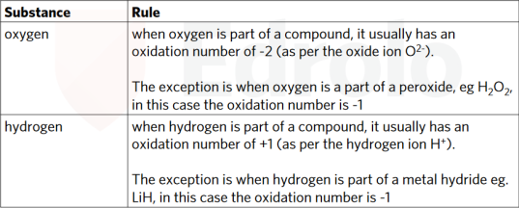
- Another method of determining if a reaction is a redox reaction.
- Oxidised – Goes up
- Reduced – Goes down
- This is not applied to electrons.
- The oxidation number is the same as its ionic charge.
Redox Reactions – Conjugate Redox Pairs
- A conjugate redox pair differs by one or more electrons.
- E.g. Fe / Fe²⁺
Ag / Ag⁺
Fe²⁺ / Fe³⁺
Redox Reactions – Writing Half-Equations
- 1. Identify the conjugate redox pair.
  - Fe²⁺ -> Fe
- 2. Add electrons to the positive side of the half-equation (balances out charges)
  - Fe²⁺ + 2e⁻ -> Fe
- 3. Check charge on reactant side = charge on product side (does not need to be 0, but does need to equal)
- 4. Add states.
  - Fe²⁺_{(aq)} + 2e⁻ -> Fe_{(s)}
- Oxidation or reduction half equations are ionic equations, because ions are present.
Redox Reactions – Writing Simple Redox Equations
- 1. Identify conjugate redox pairs.
  - Fe²⁺ -> Fe³⁺
  - Ag⁺ -> Ag
- 2. Balance half-equations (note if there are inequal numbers of electrons, add coefficients so the electrons cancel out)
  - Fe²⁺ -> Fe³⁺ + e⁻
  - Ag⁺ + e⁻ -> Ag
- 3. Check each half-equation contains the same number of electrons
- 4. Add half-reactions together and cancel electrons
  - Fe²⁺ + 2Ag⁺ + 2e⁻ -> Fe³⁺ + 2e⁻ + 2Ag
  - Fe²⁺ + 2Ag⁺ -> Fe³⁺ + 2Ag
- 5. Check charge on each side is equal
- 6. Add states.
  - Fe²⁺_{(aq)} + 2Ag⁺_{(aq)} -> Fe³⁺_{(aq)} + 2Ag_{(s)}
- NOTE: You do not see electrons in redox equations, only half-equations. This is a good way to check if you’re correct.
Redox Reactions – Writing More Complicated Half-Equations
- Some oxidising agents are polyatomic.
- Add H⁺ to balance hydrogens
- Add H₂O to balance oxygens
- E.g. (Cr₂O₇²⁻, MnO₄⁻, CH₃CH₂OH)
- 1. Identify compound containing the element that is reduced or oxidised.
  - Cr₂O₇²⁻ -> Cr³⁺
- 2. Use KOHES
  - K - Key element (except oxygen and hydrogen)
    - Cr₂O₇²⁻ -> Cr³⁺
    - Cr₂O₇²⁻ -> 2Cr³⁺
  - O - Balance O by adding H₂O
    - Cr₂O₇²⁻ -> 2Cr³⁺ + 7H₂O
  - H - Balance H by adding H⁺
    - 14H⁺ + Cr₂O₇²⁻ -> 2Cr³⁺ + 7H₂O
  - E - Balance e⁻
    - 6e⁻ + 14H⁺ + Cr₂O₇²⁻ -> 2Cr³⁺ + 7H₂O
  - S - Add states
    - 6e⁻ + 14H⁺_{(aq)} + Cr₂O₇²⁻_{(aq)} -> 2Cr³⁺_{(aq)} + 7H₂O_{(l)}
Redox Reactions – Writing Redox Equations from More Complicated Half-Equations

- 1. Use KOHES to write balanced half-equations
  - MnO₄⁻_{(aq)} + 5e⁻ + 8H⁺_{(aq)} -> Mn²⁺_{(aq)} + 4H₂O_{(l)} (equation 1)
  - Fe²⁺_{(aq)} -> Fe³⁺_{(aq)} + e⁻ (equation 2)
- 2. Balance out both sides of the equation to have the same number of electrons. This can be done using coefficients.
  - 5Fe²⁺_{(aq)} -> 5Fe³⁺_{(aq)} + 5e⁻ (equation 3)
- 3. Add equations 1 and 3 together. Cancel electrons and simplify. Remember to cancel H⁺ and H₂O as necessary.
  - MnO₄⁻_{(aq)} + 5e⁻ + 8H⁺_{(aq)} + 5Fe²⁺_{(aq)} -> Mn²⁺_{(aq)} + 4H₂O_{(l)} + Fe³⁺_{(aq)} + 5e⁻
  - MnO₄⁻_{(aq)} + 8H⁺_{(aq)} + 5Fe²⁺_{(aq)} -> Mn²⁺_{(aq)} + 4H₂O_{(l)} + Fe³⁺_{(aq)}
Redox Reactions – Metal Displacement Reactions
- Activity series of metals
- A metal displacement reaction is a type of redox reaction.
- A more reactive metal will displace a less reactive metal ion in solution.
  - E.g. Fe_{(s)} + CuSO_{4(aq)} -> FeSO_{4(aq)} + Cu_{(s)}
- The Electrochemical Series
  - Written as a series of reduction reactions (gains electrons)
  - Instead of using the activity series of metals, the electrochemical series can be used to determine whether a metal displacement reaction will occur spontaneously.
  - Strongest oxidising agents are on the left-hand-side going from top to bottom of the equations.
  - Strongest reducing agents are on the right-hand-side going from bottom to top of the equations.
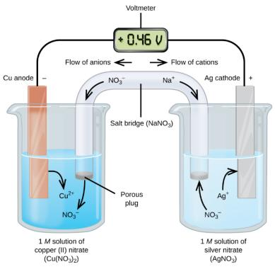
  - If a negative gradient is found between the oxidising and reducing agent, then they will react spontaneously.
  - Reactions can go in reverse (equilibrium arrows)
  - A metal low in the activity series will displace a higher metal from solutions of its salt.
  - Metals above copper will react with dilute acids.
  - Calcium and metals higher in activity series will react with water.
Redox Reactions – Metal Displacement Reactions in Galvanic Cells
- Galvanic cell = battery.
- Anode – site of oxidation (An Ox)
- Cathode – site of reduction (Red Cat)
- Zinc anode reduces in mass (corrodes), copper cathode gains mass (grows) because Cu_{(s)} is being deposited on the cathode.

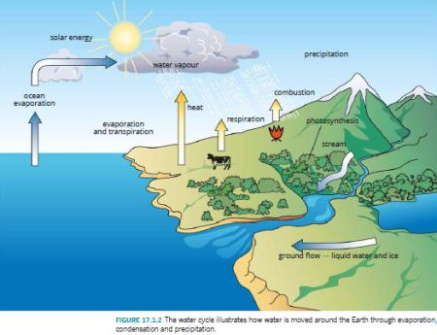
Unit 2 AOS 2 – How are substances in water measured and analysed?

Water Sample Analysis
Water Sample Analysis – Sources of Water
- Solar energy is the primary energy source for the water cycle. (evaporation)
- Water volume on Earth categorised in descending order:
  - Ocean
  - Ice caps & glaciers
  - Groundwater
  - Ground ice & permafrost
  - Lakes
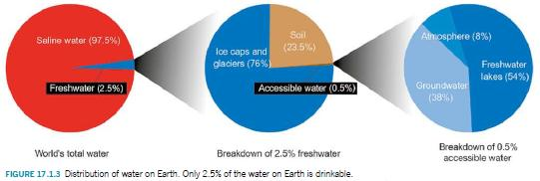
  - Soil moisture
  - Atmosphere
  - Rivers
- Surface water and ground water (aquifer) exist.
- Only 2.5% of water on Earth is “fresh” (i.e. ice caps)
- <1% of water on Earth is accessible and drinkable.
- Drinking water is found in:
  - Reservoirs (reticulated water)
  - Rivers & lakes
  - Groundwater
  - Recycled
  - Desalinated
- Temperature
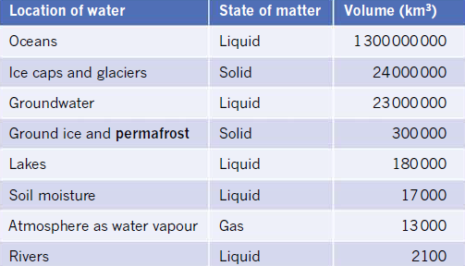
  - Affects measurements of pH, dissolved oxygen and electrical conductivity.
  - Thermometers or probes are used to record the temperature of sampled water, and depth needs to be recorded.
- Self-ionisation
  - The temperature of pure water causes the pH to vary.
- pH
  - Most marine animals tolerate pH of 6.5-8.0
  - Universal indicator solution or litmus paper connected to a computer.
  - Best to measure pH within 2 hours of sampling water (before oxygen releases)
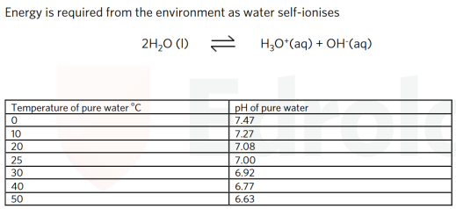
- Electrical conductivity
  - Measure of dissolved salts in water
  - Can be measured using a portable conductivity meter or probe.
- Turbidity (cloudiness)
  - Can be measured using a sensor or Secchi Disk below the surface of the water until it disappears.
  - Lake water has high turbidity due to the suspension of particles.
- Dissolved oxygen
  - Concentration of oxygen decreases with increasing temperature
  - Level of dissolved oxygen is also dependent on photosynthesis from marine plants
  - Fish absorb oxygen through respiration.
  - Dissolved oxygen is measured via a sensor connected to a computer.
  - Biological oxygen demand (BOD)
    - Measure of organic pollution in water and of oxygen consumed in chemical reactions
    - Higher the biological oxygen demand, the greater the level of decomposing matter in the water.
    - Measured via taking samples of water several days apart and analyzing them using sensors.
Water Sample Analysis – Contaminants in Water
- Chemical contaminants
  - Industrial waste
  - Agricultural pesticides, herbicides, fungicides, etc.
  - Landfill (i.e. lead, cadmium, plastic)
  - Mining (i.e. sulphur dioxide)
  - Car exhausts
  - Oil spills (occur in seas)
Water Sample Analysis – Obtaining Samples
- Protocols for sampling
  - 1. Container can be rinsed with the sample before the sample is taken.
  - 2. Container should be cleaned before obtaining another sample.
  - 3. Water used to clean should be tested to ensure no contamination between samples.
  - Depth should be considered, where if temperature is consistent, then it is assumed the water is mixed evenly, but if there is temperature variation, then samples should be taken from each metre-long strata of water.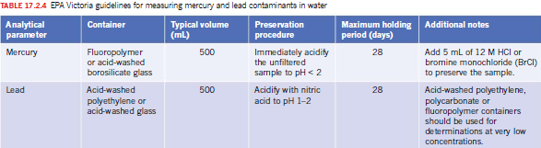

Measurement of Solubility & Concentration
Measurement of Solubility & Concentration – Introduction to & Application of Solubility Curves
- Solubility Curves
  - Obtained by determining the maximum mass of solute that will dissolve in an arbitrary volume at an arbitrary temperature.
  - If more than the maximum mass of solute is added, crystals of solute will be observed.
  - Saturated
    - No more solute can dissolve at a temperature
  - Unsaturated
    - More solute can dissolve at a temperature
  - Supersaturated
    - Unstable solution containing more solute than normal (usually heated) and can be easily broken if disturbed.
Measurement of Solubility & Concentration – Solubility of Gases in Water
- Solubility of gases in water decrease as the water temperature increases.
- This is because gases evolve as bubbles and evaporate from the water.
Measurement of Solubility & Concentration – Units of Concentration in Solutions
- $n=cV$, $n=\frac{m}{M}$
- n = amount of substance (mol)
- c = concentration in molarity (mol L^-1 or M). Don’t confuse this with molar mass.
- V = volume of solution in L.
- Always specify units.
- Convert from M to g/L
  - M = mol of X in 1.00 L of solution.
  - Find m by multiplying mol by molar mass. (m = n * M)
- Molarity asks for concentration. = mol/L
Measurement of Solubility & Concentration – Converting Percentage Concentration to Molarity

Analysis for Salts in Water
Analysis for Salts in Water – Sources of Salt in Water & Conductivity
- Rainwater is slightly acidic because of CO₂ from the atmosphere forming carbonic acid (H₂CO₃)
- Carbonic acid causes erosion on land and the ions seep into oceans, dissociating into Na⁺ and Cl⁻ making sea water salty.
- Underwater volcanoes, geysers, etc. release minerals from within the earth into the sea water.
- More salt in the sea = more electrical conductivity (presence of ions in water carrying energy)
- Units of conductivity are siemens (S), which are the opposite of resistance ohms (Ω)
- The more distilled the water, the less conductive it is.
- Heavy metals have a high density, and have a toxic effect on living organisms.
- ‘Hard’ water refers to high level of metal ions such as Ca²⁺, Mg²⁺, Fe²⁺.
- TDS – total dissolved solids; concentration of inorganic & organic substances dissolved in water.
Analysis for Salts in Water – Mass-mass Stoichiometry
- Gravimetric analysis
  - Filter is used on funnel to separate solution and precipitate
  - Vacuum filter can also be used which is faster and more efficient.
- Chemical equations that involve precipitation reactions in water can be gravimetrically analysed.
Analysis for Salts in Water – Principles of Colorimetry & UV-visible Spectroscopy
- Some ions absorb visible and ultraviolet light.
- Colorimeters and UV-visible spectrometers can detect these waveforms.
- Metal complex – metal ion bonded to molecules or anions. Solutions of many metal complexes can be analysed through colorimetry or UV-visible spectroscopy.
- Amount of light absorbed is proportional to the concentration of the solution (i.e. concentrated = more atoms = more photons absorbed)
- Used to measure amount of coloured substances in water (ions and/or complexes)
- Light absorbed in solution is proportional to the concentration of a coloured ion or complex.
- Calibration curves are made by measuring the absorbance of light in a series of standard solutions of known concentration.
- UV-visible Spectrophotometer
  - Coloured solution may be placed into a UV-visible spectrophotometer.
  - Uses monochromator in place of a filter.
  - Wavelength is selected (where substance absorbs strongly) which the absorbed light excites electrons in ions or complexes to higher energy levels.
- Colorimeter
  - Complementary colours
    - If a solution appears orange, it must be absorbing complementary (blue) wavelengths of light.
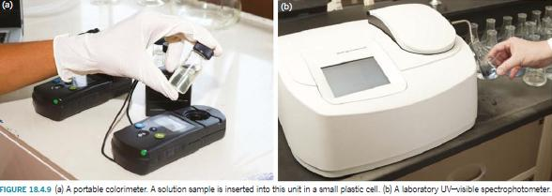
    - Colorimeters should use a filter complementary to what the observed colour of the solution is.
Analysis for Salts in Water – Application of Colorimetry & UV-visible Spectroscopy
- Beer-Lambert Law
  - “The absorbance of a solution is proportional to the concentration of coloured substance in solution.”
- A series of standard solutions is prepared and put into a colorimeter or UV-Visible Spectrophotometer to measure absorbance.
- Plotting a Calibration Curve
  - X-axis: concentration of substance in solution (incl. units)
  - Y-axis: Absorbance (no units)
  - Draw a line of best fit through data points.
Analysis for Salts in Water – Application of AAS to Determine Concentration
- When an element is heated, it may rise to a higher energy level (shell) and when moving back down it’ll emit electromagnetic radiation as light (emission spectrum)
- Emission spectra are unique to each element.
- Flame tests are performed by inserting a sample into a colourless flame.
- Flame tests are not used often because of the fallacies of the human eye being unable to distinguish between small colour changes.
- Atomic Absorption Spectroscopy (AAS)
  - Analytical technique used to measure concentration of metals or metal ions in a water sample.
  - Special lamp made of the metal element is used (e.g. if measuring Pb²⁺, the lamp will be made of Pb)
  - Series of standard solutions is inserted into the spectrometer and absorbance is recorded.
  - Absorbance of unknown sample is measured.
  - Concentration of unknown sample is read from calibration curve.

Analysis for Organic Compounds in Water
Analysis for Organic Compounds in Water – Sources of Organic Compounds in Water
- Organic pollutants – agriculture
  - Pesticide
  - Herbicide
  - Fungicide
  - Pesticides are often soluble in water.
- Persistent organic pollutants (POPs) from industry
  - Slow to degrade.
  - Dioxins (PCDDs)
    - Formed from incineration of organic compounds containing chlorine.
    - Also produced in heavy metal industries such as metal smelting and paper production.
  - PCDFs
  - PCBs
  - Typically come from landfill runoff, discharge of waste chemicals, power transformers, plasticisers, adhesives, PVC insulation, hydraulic fluids
  - These pollutants often have benzene rings.
  - Many pops are carcinogenic and affect the nervous and reproductive systems of living things.
  - Often accumulate in fats and are insoluble in water.
  - Levels can be higher in organisms high on the food chain.
  - Better guidelines and less toxic alternatives have reduced emissions since the 2001 Stockholm Convention.
  - Frequent oil spills makes a constant source of organic contamination.
Analysis for Organic Compounds in Water – Application of HPLC to Determine Concentration
- Principles of paper chromatography
  - Technique used to separate mixtures of substances.
  - 1. Stationary phase
  - 2. Mobile phase (solvent)
  - Separation of mixture depends on how the substance bonds to stationary and mobile phases.
  - Qualitative analysis. Known standards are added to the stationary phase to enable identification.
- High Performance Liquid Chromatograph (HPLC)
  - Machine with mobile phase uses a pump and sample in syringe to inject into a column (stationary phase) where a detector leads to a display.
  - More complex and expensive, both qualitative (type of substance) and quantitative (how much).
  - Outputs as chromatogram.
    - Peaks = number of substances
      - Height of peaks = concentration of a substance
    - Retention time = type of substance
    - Comparing a known standard that corresponds with the same time, that’s how a substance can be identified.
- Increasing molar mass = increased retention time.
  - Substance with the lowest molar mass will show up first.

Analysis for Acids & Bases in Water
Analysis for Acids & Bases in Water – Sources of Acids & Bases in Water
- Occurs from many places (e.g. mining, industrial waste, car pollution, etc.)
- Cars emit nitrogen oxide gases (NO_{x})
- In mining, sulphur oxide gases are produced (SO_{x})
- Nitrogen oxide and sulphur oxides seep into water, causing acid rain, causing detrimental effects towards ecosystems and can corrode buildings.
- Formation of carbonic acid
  - CO_{2(g)} + H₂O_{(l)} ⇌ H₂CO_{3(aq)}
  - H₂CO_{3(aq)} + H₂O_{(l)} ⇌ HCO₃⁻_{(aq)} + H₃O⁺_{(aq)}
  - As CO₂ levels increase, more CO₂ is absorbed into the oceans.
  - When CO₂ is absorbed into oceans and binds with water, carbonic acid forms and the pH of the water falls, making it more acidic. This can cause mass deaths for marine life underwater.
  - This reaction also occurs in our cells, using oxygen in blood, producing carbon dioxide as a waste product. This can go into the blood to form carbonic acid and ultimately hydronium ions and hydrogen carbonate ions where it is then taken back to the lungs, and is converted back into CO₂ as a waste product and it is exhaled.
Analysis for Acids & Bases in Water – Standard Solutions
- “A solution with an accurately-known concentration.”
- Accurately-known mass of solute is dissolved in an accurately-known volume of distilled water.
- Glassware is known as a ‘standard’, or ‘volumetric flask.’
- Bottom of meniscus is perfectly placed at the calibration line.
- Primary Standard
  - Used to standardise other solutions.
  - Has a known chemical formula
  - Can be obtained in a pure form
  - Easy to store without deteriorating or reacting with the atmosphere
  - Relatively high molar mass
  - Inexpensive
  - E.g. Na₂CO3, K₂CO_{3,} C₈H₅KO₄
  - “Anhydrous Na₂CO₃ is a primary standard. 1.352g of this is transferred to a 250mL standard (volumetric) flask. Distilled water is added to make a standard solution. Determine the molarity of the standard solution.”
    - 1. Calculate mass in mol of Na₂CO₃
    - 2. Use c = n/V to find the molarity of the standard solution.
  - “A chemist wants to make a standard sodium carbonate solution of concentration 0.1000M. What mass of anhydrous sodium carbonate should be weighed and added to a 200mL flask?
    - 1. Use n = cV to find the mass in number of moles of sodium carbonate that is needed.
    - 2. Use m = n * M to find the mass in grams of the sodium carbonate that is needed.
    - 3. State distilled water needs to be filled up to the calibration line.
Analysis for Acids & Bases in Water – Acid-Base Titrations
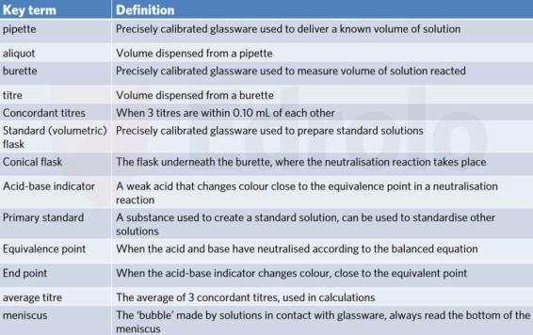
- Used to determine the concentration of an unknown solution.
- Flasks must be cleaned only with distilled water.
- Pipettes must be rinsed with the substance first before dispensing the aliquot (i.e. rinse acid into pipette before placing into solution)
- Steps in a titration
  - 1. Known volume of solution measured using a pipette into a conical flask (aliquot)
  - 2. Other solution dispensed slowly from a burette (titre)
  - 3. Equivalence point is the stoichiometric ratio (mole ratio in a stoichiometric equation)
  - 4. To minimise errors, the titration is repeated until all concordant titres (within 0.10mL) are obtained, average titre is used in calculations.
- “A solution of hydrochloric acid was placed in a burette. A 25.00mL aliquot of 0.102M sodium hydroxide solution was dispensed into a conical flask. A few drops of bromothymol blue indicator were added. The average concordant titre of HCl was 25.46mL. Calculate the concentration of the hydrochloric acid solution.”
  - 1. Write a balanced reaction (and annotate information if necessary)
  - 2. Calculate the amount of substance in mol of known substance. (n = cV)
  - 3. Calculate the amount of substance in mol of unknown substance (will be the same ratio as the known substance)
  - 4. Calculate the required quantity (c = n/V)
Analysis for Acids & Bases in Water – Choosing a Suitable Acid-Base Indicator
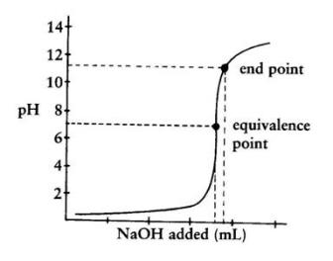
- Titration curve (x-axis = titre in burette, y-axis = pH)
  - Equivalence point – sharp change in pH. Halfway shows the point where acid + base neutralise.
  - Note: equivalence point is not necessarily pH = 7. If a conjugate acid/base is created, this will not be 7.
  - End point – final change in pH before plateauing.
- Different indicators exist for different short pH ranges. Universal indicator is a combination of several indicators.
- The end point is where colour change occurs, not the equivalence point.
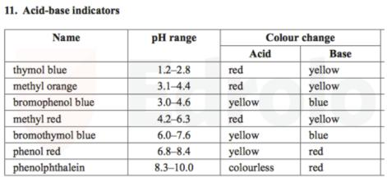
Analysis for Acids & Bases in Water – Concordant Titres
- Typically, a titration experiment is completed three times until all results are concordant, all within a maximum range of 0.10mL (~2 drops)
- Average titration can be calculated.
Analysis for Acids & Bases in Water – Titrations Involving Diluted Solutions
- Solutions are often diluted before titration to become more accurate. One drop (0.05mL) of a titre is much easier to detect if a solution is more dilute.
- “Vinegar containing ethanoic acid was diluted prior to undertaking an acid-base titration. A 25.00mL aliquot of the vinegar was placed into a 250.0mL standard flask. A 20.00mL aliquot of the diluted vinegar was placed into a conical flask and titrated with 0.100M NaOH with acid-base indicator. The average concordant titre of NaOH was 9.32mL. Calculate the concentration of ethanoic acid in the undiluted vinegar.”
  - 1. Write balanced equation and annotate.
  - 2. Calculate amount of known substance in mol. (n = cV)
  - 3. Calculate amount of unknown substance in mol (equivalent ratio)
  - 4. Calculate required quantity in diluted solution. (c = n/V)
  - 5. Calculate required quantity in concentrated solution by using the diluted solution concentration as c₂. (c₁ = c₂V₂/V₁)

